**Converting from a Conceptual & Logical Data Model to a Physical Data Model**

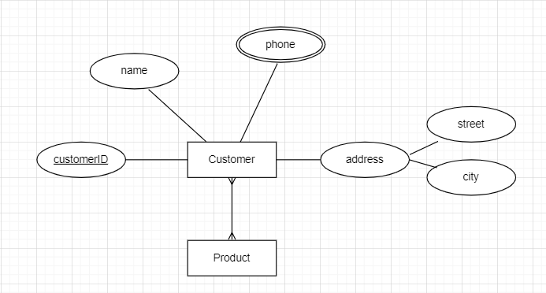

**Step 1 – Convert entities to tables**

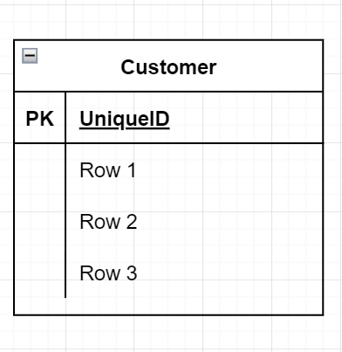

**Step 2 – Identify primary key**

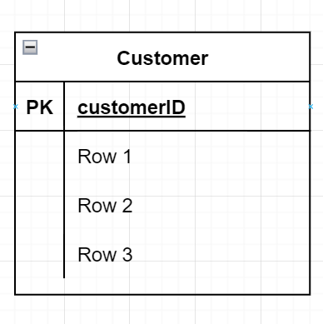

**Step 3 – List all attributes**

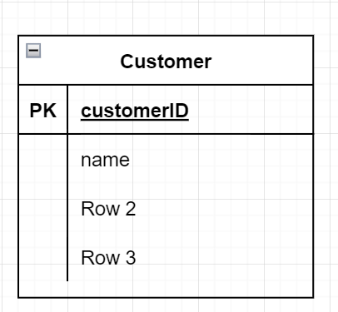

**Step 4 – List all components of each composite attribute**

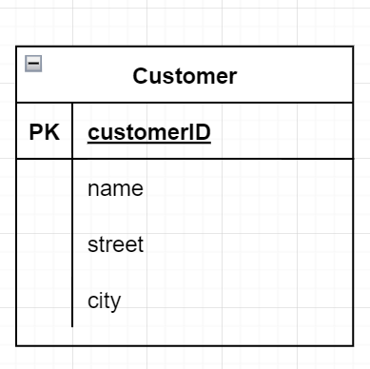

**Step 5 – Create a new table to store multivalued attributes**

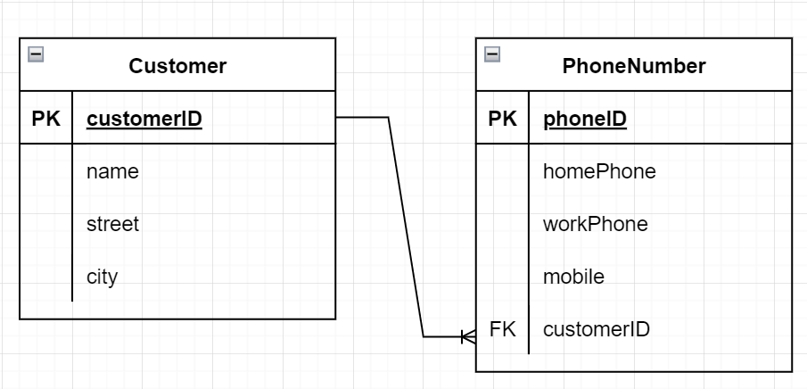

**Step 6 - Create an additional table to convert Many to Many relationships to two One to Many relationships.**

